GSM Bug Listening Device N9
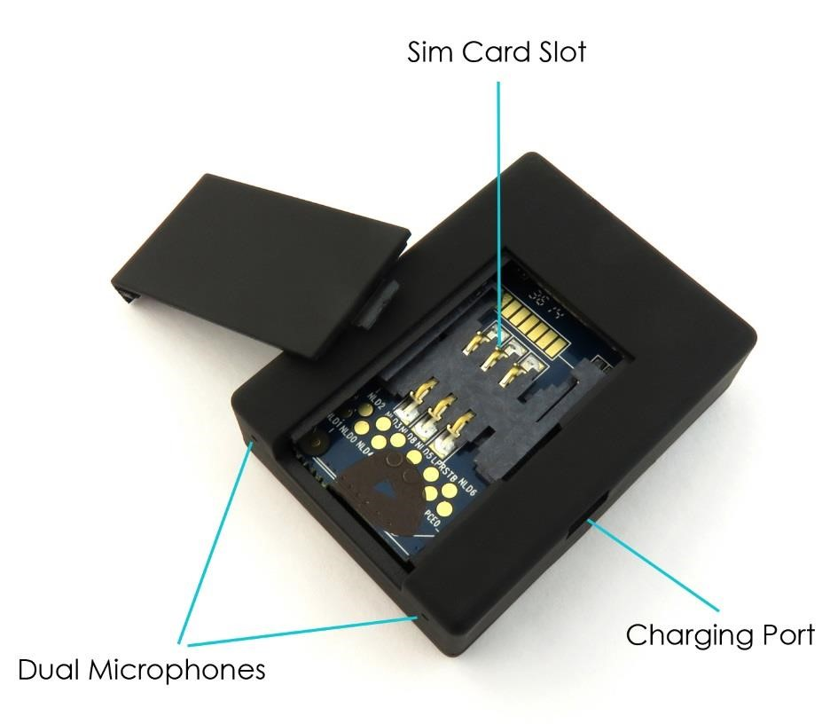
Above shows the main features of the GSM listening bug. it uses dual microphones for better sound pickup, includes a charging port on the side and the SIM card slot is located in the back.
Basic Listening Function: If you would like to hear what is happening around the GSM Bug listening device then you can simply call the number of the SIM card that you placed in it.
Call out function: To use this feature you must first ensure that you put in a SIM card with credit on, this could be a pay as you go or pay monthly contract.
Enable: Send a text to the GSM bug SIM with the code 888; you will receive a text confirming that the Call Out function has been enabled.
Disable: If you wish to disable the Call Out function send the GSM Bug a text with the code 444; this will again send you a confirmation text to say it has been disabled.
SMS Notification: Similar to the Call Out function you can set the GSM listening bug to text you a whenever there is any sound above 60BD.
Enable: Send a text to the GSM bug SIM with the code 777; you will receive a text confirming that the SMS notification function has been enabled.
Disable: To cancel the SMS notifications you send the text 444;
GPS Tracking: Text DJ (in capitals) to the GSM Bug and it will text back with both Latitude and Longitude coordinates enabling you to find out where the bug is.
Battery Level Check: Text 666; and it will respond with one of the following replies: 1) Tracker Battery Full 2) Tracker Battery Half Full 3) Tracker Battery Low
Troubleshooting: If you are having trouble using the device please go through the following point
1) Is the sim card you are using registered? has it been topped up with credit and tested in a mobile phone to see if it works?
2) Are you using a recommend mobile network sim card ie EE, Vodafone, 02
3) Did you charge up the listening device before use?
4) Have you checked the sim card is in the correct way round as it is in the photo below
